***Objective :***

* Triggers
* Statement level triggers
* Raising Custom error

Emp(empid,empname, Sal, Comm)

Audit(tablename,transaction,createdby,date)

**Question no 1:**

Write a trigger to prevent updating and inserting in sal column every month 16 till 17, and raise an custom exception if user attempt to update.

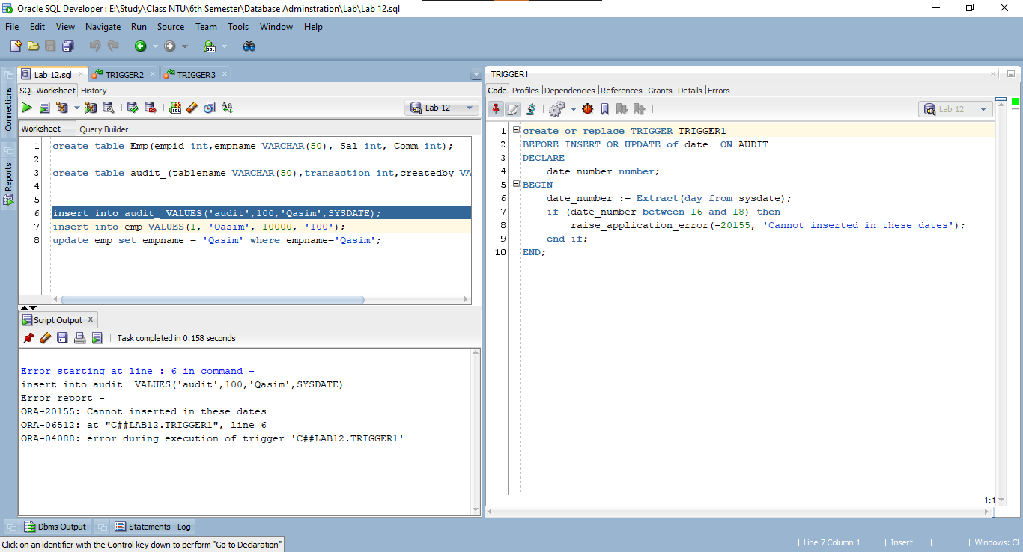

**Question no 2:**

**Create a trigger to prevent update and deletion on empname and raise custom exception.**

**Question no 3**

**Create a trigger that record each transaction on Emp table and insert it in audit table (schema of audit table is given above)**

